Multiscale modelling   
First report (completed classes: 1-4)  
Konrad Tabiś

1. **Technology**

To implement this project I choose Java programming language, because it is class-based, object-oriented. Additionally Java allows developers write once, run anywhere (WORA), meaning that compiled Java code can run on all platforms that support Java without the need for recompilation. A prior knowledge of this programming language was also a very important factor in this choice.

The JavaFX Scene Builder application was used to create the GUI, which speeds up the work with interface. JavaFX Scene Builder is a visual layout tool that lets users quickly design JavaFX application user interfaces, without coding. Users can drag and drop UI components to a work area, modify their properties, apply style sheets, and the FXML code for the layout that they are creating is automatically generated in the background. The result is an FXML file that can then be combined with a Java project by binding the UI to the application’s logic.

To implement this project IDE created by JetBrains - IntelliJ IDEA was used. The powerful static code analysis and ergonomic design make development not only productive but also an enjoyable experience.

1. **Application**

The created application looks as follows and the available functionalities will be presented below

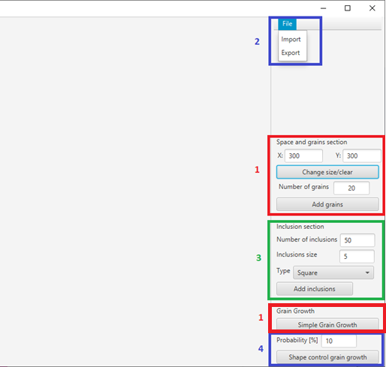

Figure 1 Application GUI

Every number on figure 1 responds functionality associated with one classes.

The first area allows resizing, clearing CA space, adding grains and growing grains(Moor neighbourhood). Maximal size of CA space is 1000 x 1000.

The second area allows import and export generated structure to txt or png file.

The third area allows adding inclusions (before or after simulation). The application allows to choose the number of inclusions, their size and type (squere or circular).

The fourth area allows creating shape control grain growth with probability for the fourth rule in simulation entered by the user.

1. **Example of application operation**

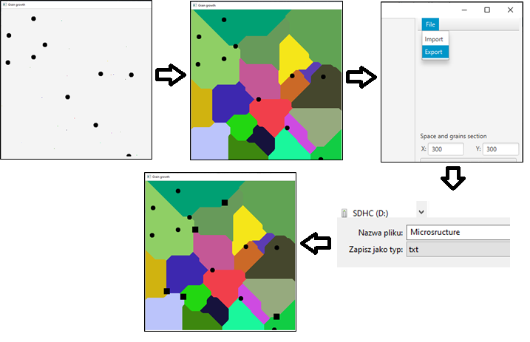

Figure 2 First example of program operation

First example of program operation presents creation CA space with 300x300 size and addition 10 circular inclusions with size equal to 5. The next step was to add 20 grains and simple grain growth. After simulation structure was saved to txt file (presented on figure 3). The last step was to add squere inclusion after simulation. They are located on grains boundaries.

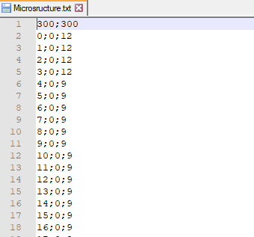

Figure 3 Txt file with structure

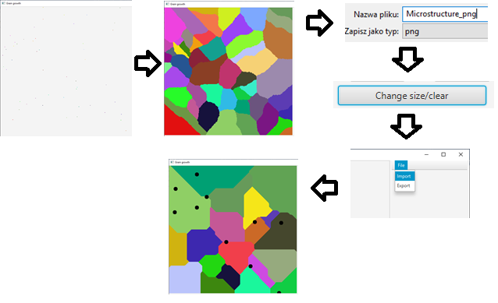

Figure 4 Second example of program operation

Second program scenario presents shape control grain growth with probability for fourth rule equal 70%. For this simulation was used 50 grains. Then the structure was saved to png file. After saving, space was cleared. Saved structure from first example has been loaded.

1. **Application versus real microstructure**

To check the effectiveness of the application, structure will be created based on the real model of carbon steel (figure 5).

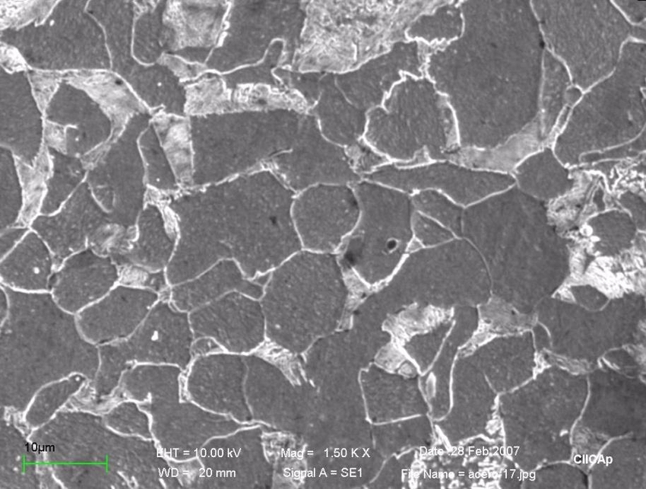

Figure 5 Optical image of the microstructure of carbon steel [1]

To map the microstructure, at the beginning one inclusion was added, which is visible on optical image of the microstructure of carbon steel. Then 70 grains were added to make their size similar to the real size and simulated shape control grain growth with 70% probability to fulfill fourth rule.

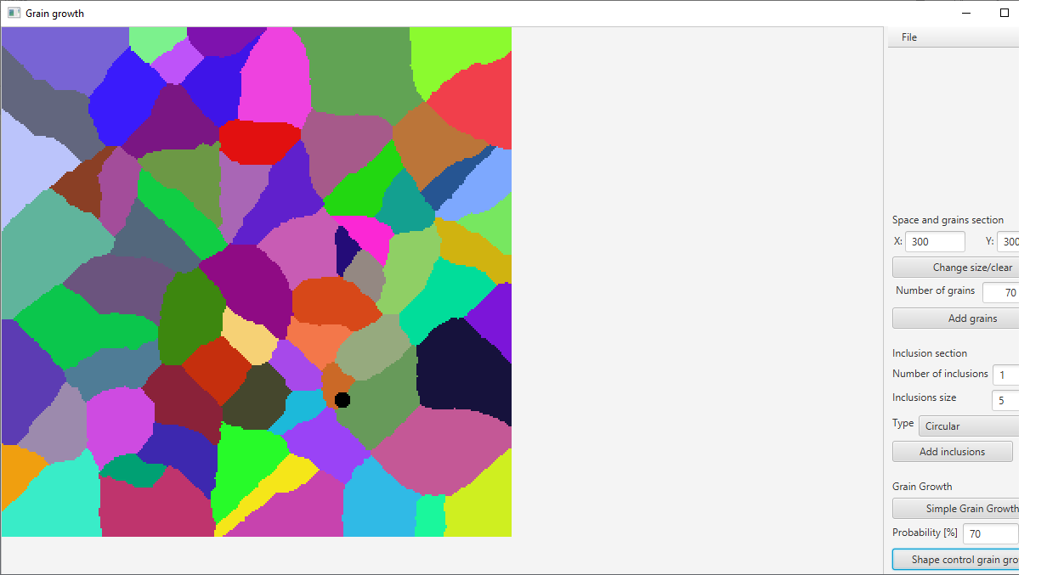

Figure 6 Simulated structure

The simulated structure does not fully reflect the real microstructure, but some similarities can be seen.

The project has not been fully implemented and it interferes with the more accurate reflection of the microstructure. Even at this level the application can generate microstructures similar to real ones.

As further steps it would be necessary to implement the missing functionalities and also improve the grain growth algorithm, because with a large size space it takes even a few seconds to present results.

1. **Sources**

[1] „Comparison of Corrosion Resistance of Carbon Steel and Some Stainless Steels Exposed to LiBr-H2O Solution at low Temperatures” *C. Cuevas Arteaga, J. Porcayo Calderón, C. F. Campos Sedano, J. A. Rodríguez,* 2012